**ONLINE GROCERY ORDERING IN MADURAI CITY**

**Project work submitted in Partial fulfillment of the requirements for the award of the degree of**

## BACHELOR OF SCIENCE IN COMPUTER SCIENCE

**Submitted by**

### T H PRIYADHARSHINI (19UCS34)

**Under the Guidance of**

### Dr. K. NATARAJAN Ph.D.,



**DEPARTMENT OF COMPUTER SCIENCE**

**THIAGARAJAR COLLEGE (AUTONOMOUS)**

#### (Affiliated to Madurai Kamaraj University)

**Re-Accredited with ‘A++ Grade’ by NAAC**

**Ranked 23rd in NIRF**

**MADURAI-625 009**

**MAY 2022**

### THIAGARAJAR COLLEGE (AUTONOMOUS)

**(Affiliated to Madurai Kamaraj University)**

### Re-Accredited with ‘A++ Grade’ by NAAC

**Ranked 23rd in NIRF**

### DEPARTMENT OF COMPUTER SCIENCE

### BONAFIDE CERTIFICATE

This is to certify that **“ONLINE GROCERY ORDERING IN MADURAI CITY”** is a bonafide project work done by **T H PRIYADHARSHINI (19UCS34)** of B.Sc Computer Science during the sixth semester. Submitted for the viva-voce held on _________________.

**Project Guide Head of the Department**

**(Dr.K.NATARAJAN) (Mrs.SM VALLI)**

### External Examiner

**T H PRIYADHARSHINI (19UCS34)**

**B.Sc., Computer Science,**

**Department of Computer Science,**

**Thiagarajar College (Autonomous),**

**Madurai - 625009.**

## DECLARATION

Hereby, I declare that this software product **“ONLINE GROCERY ORDERING IN MADURAI CITY”** has been done thoroughly at the outset of my knowledge and has not been drafted out to any other modes of information. This software has been purely developed by me.

**Place :**

**Date : Signature**

**(Name : )**

**(Reg.No : )**

# ACKNOWLEDGEMENT

## ACKNOWLEDGEMENT

First and Foremost, I am Grateful to thank the Almighty Lord who has showered his blessings on me, all through my life and Wisdom for providing the ability to use knowledge in bringing this project.

I whole heartedly thank the Management for the golden opportunity given to me to study in this esteemed Institution. I take great delight in expressing my thanks to our Principal **Dr. D. PANDIYARAJA M.Sc., M.Phil., PGDCA., B.Ed., Ph.D.,**

Thiagarajar College, Madurai for giving an opportunity to study in this institution. My special and sincere thanks to **Mrs. SM. VALLI B.E., M.C.A., M.Phil.,** Associate Professor and Head, Department of Computer Science, Thiagarajar College, Madurai for providing laboratory facilities and her timely support as well throughout the project work.

We are immensely pleased to record my profound gratitude and heartfelt thanks to my guide, **Dr.K.NATARAJAN Ph.D.,** Associate Professor, Department of computer Science, Thiagarajar College, Madurai for his continuous guidance, supervision, encouragement and valuable suggestions throughout the entire project work.

I thank all the faculty members of Computer Science department for their Cooperation. Above all, I am grateful to thank in personal to my family and friends for their continuous encouragements.

Finally, I thank all those who have helped us directly and indirectly for the successful completion of my project.

**CONTENT**

|  |  |  |
| --- | --- | --- |
| S.NO | TITLE | PAGE.NO |
| **1** | **INTRODUCTION**   * 1. ABSTRACT   2. ABOUT THE PROJECT | 2  3 |
| **2** | **SYSTEM CONFIGURATION**   * 1. HARDWARE REQUIREMENTS   2. SOFTWARE REQUIREMENTS   2.3 SOFTWARE SPECIFICATIONS | 5  5  6 |
| **3** | **SYSTEM ANALYSIS**  3.1 EXISTING SYSTEM  3.2 PROPOSED SYSTEM | 10  10 |
| **4** | **SYSTEM DESIGN**   * 1. DATA FLOW DIAGRAM   2. DATABASE STRUCTURE   3. MODULES | 12  15  19 |
| **5** | **SYSTEM IMPLEMENTATION**  5.1 SYSTEM IMPLEMENTATION  5.2 SAMPLE CODINGS | 22  24 |
| **6** | **SYSTEM TESTING**   * 1. TESTING   2. TYPES OF TESTING | 63  63 |
| **7** | **INPUT AND OUTPUT SCREEN** | 65 |
| **8** | **CONCLUSION** | 85 |
| **9** | **FUTURE ENHANCEMENT** | 87 |
| **10** | **BIBLIOGRAPHY**  10.1 REFERENCES | 89 |

# INTRODUCTION

* 1. **ABSTRACT:**

**1. INTRODUCTION**

The main objective of the Online Grocery Ordering in Madurai City is to help the customer to ordering the grocery items through online in convenient and easier manner. For a customer, it can minimize the workload and effort of going around the grocery shop to order the items they are looking for and also they can compare the price and availability of the item in various grocery shop.

#### ABOUT THE PROJECT:

The project aimed at creating a virtual shop environment for users, in some handy form, which will be available to them through the internet. This will be more convenient for the users. The main objective of this application is to make it interactive and its ease of use. This project is mainly build for Madurai city. This is very useful for local vendors. Many online shopping websites are available but Online Grocery Ordering in Madurai city is mostly made for small scale vendors. So that they can also grow up. The shopkeeper can add their products, update and delete their products. Users can compare the price and availability of the items in various shops. Thus the customer will get the service and home delivery from his favorite shop.

**SYSTEM CONFIGURATION**

## SYSTEM CONFIGURATION

### HARDWARE REQUIREMENTS

OPERATING SYSTEM : Windows10

PROCESSOR : AMD PRO A4-4350B R4

RAM : 2 GB

HARD DISK : 414GB

### SOFTWARE REQUIREMENTS

TECHNOLOGY : PHP

WEB-TECHNOLOGIES : HTML, CSS, JAVASCRIPT

WEB SERVER : APACHE

DATABASE : MYSQL

### SOFTWARE SPECIFICATION

**2.3.1 HTML: Hyper Text Markup Language**

It is the standard markup language for creating web pages and web applications. With Cascading Style Sheets (CSS) and JavaScript, it forms a triad of cornerstone technologies for the World Wide Web. Web browsers receive HTML documents from a web server or from local storage and render the documents into multimedia web pages. HTML describes the structure of a web page semantically and originally included cues for the appearance of the document.

HTML elements are the building blocks of HTML pages. With HTML constructs, images and other objects such as interactive forms may be embedded into the rendered page. HTML provides a means to create structured documents by denoting structural semantics for text such as headings, paragraphs, lists, links, quotes and other items. HTML elements are delineated by tags, written using angle brackets. Tags such as <img> and <input> directly introduce content into the page. Other tags such as <p> surround and provide information about document text and may include other tags as sub-elements. HTML can be embedding programs written in a scripting language such as JavaScript, which affects the behavior and content of web pages. Inclusion of CSS defines the look and layout of content.

**2.3.2 CSS: Cascading Style Sheets**

It is a style sheet language used for describing the presentation of a document written in a mark-up language like HTML. CSS is a cornerstone technology of the World Wide Web, alongside HTML and JavaScript. It is designed to enable the separation of presentation and content, including layout, colors, and fonts. This separation can improve content accessibility, provide more flexibility and control in the specification of presentation characteristics, and enable multiple web pages to share formatting by specifying the relevant CSS in a separate .css file. The name Cascading comes from the specified priority scheme to determine which style rule applies if more than one rule matches a particular element. This cascading priority scheme is predictable. The CSS specification are maintained by the World Wide Web Consortium (W3C).

A style sheet consists of a list of rules. Each rule or rule-set consists of one or more selectors, and a declaration block. In CSS, selectors declare which part of the markup a style applies to by matching tags and attributes in the markup itself. Elements are specified by attributes, in particular id or class. Each web browser uses a layout engine to render webpage, and support for CSS functionality is not consistent between them.

**2.3.3 JAVASCRIPT:**

Javascript is the most popular programming language in the world and that makes it a programmer’s great choice. Javascript, helps you developing great front-end as well as back-end softwares using different Javascript based frameworks like jQuery, Node.JS etc. Javascript is everywhere, it comes installed on every modern web browser and so to learn Javascript you really do not need any special environment setup. For example Chrome, Mozilla Firefox , Safari and every browser you know as of today, supports Javascript. Javascript helps you create really beautiful and crazy fast websites. JavaScript usage has now extended to mobile app development, desktop app development, and game development. This opens many opportunities for you as Javascript Programmer. Due to high demand, there is tons of job growth and high pay for those who know JavaScript. You can navigate over to different job sites to see what having JavaScript skills looks like in the job market.

**2.3.4 PHP (PHP, Hypertext Pre-processor):**

Php is a scripting language originated in 1995 by a software development contractor named Rasmus Lerdorf. It has developed as one of the best larger scripting languages around the globe .PHP is a server-side scripting language that was introduced for developing dynamic web applications. PHP code is embedded into HTML source file with PHP tags and interpreted by web server. Its syntax is a mixture of C, Java and Perl languages. PHP became very famous among developers because of its easy connectivity to MySQL databases that leads to creating dynamic web sites. PHP can be used from command line interface or in standalone graphical applications. It can be deployed on any server and any operating system easily. Figure shows the syntax of PHP code in an HTML file. PHP starting and ending tags makes it available anywhere in the page to use it as scripting language.

**2.3.5 XAMPP Server:**

The most obvious characteristic of XAMPP is the ease at which a WAMP webserver stack can be deployed and instantiated. Later some common packaged applications that could be easily installed were provided by Bitnami. Officially, XAMPP's designers intended it for use only as a development tool, to allow website designers and programmers to test their work on their own computers without any access to the Internet. To make this as easy as possible, many important security features are disabled by default. XAMPP has the ability to serve web pages on the World Wide Web. A special tool is provided to password protect the most important parts of the package. XAMPP also provides support for creating and manipulating databases in MariaDB and SQLite among others. Once XAMPP is installed, it is possible to treat a local host like a remote host by connecting using an FTP client. Using a program like FileZilla has many advantages when installing a content management system (CMS) like Joomla or WordPress. It is also possible to connect to localhost via FTP with an HTML editor.

**2.3.6 APACHE:**

Apache is an open source HTTP web server, which is the primary part of MAMP. Because of its speed, reliability and security, it is the world’s most used web server software. Apache is a powerful and flexible web server. It is developed and maintained by Apace Software Foundation. Apache server is used in a PHP implementation. It has the features of running virtually on all computer platforms. Apache users can have a lot of support from its website. The usage of Apache is more when it comes to usage when compared to other web servers. Figure illustrates the usage of web server around the word and also the statistics for usage of web servers. Figure above shows the comparison between the Apache server and other servers. Many big companies around the world are currently using Apache server. Its usage percentage is more than the half of the total. The main feature of Apache is that it is easy and flexible.

**2.3.7 MYSQL:**

A database is a collection of useful information that can be easily accessed, modified, managed and updated. It is use to provide efficient retrieval. The data, which is stored in a database, can be in any format .MySQL is an open source Relational Database Management System (RDBMS) that uses Structured Query Language (SQL). The main features of using MySQL are that it is very user friendly, easy to use, quickly processing and flexible. Because it is a relational database, it stores data in different tables making it possible to use same data flexibly in different ways. MySQL server controls the access to project data and makes sure that multiple users can work parallel with the same data with fast and easy access. It also restricts to the authorized users who can have access to the data. Many large and medium scale companies are using MySQL to save money and time keeping their high volume, critical business systems. MySQL is easy to use and of a high reliability. It is very light weight and can run on over 20 different operating systems. MySQL database contains tables, where each table contains rows, with each row containing columns where data is stored. Figure shows the basic structure of a MySQL table with rows and columns.

# SYSTEM ANALYSIS

## 3. SYSTEM ANALYSIS

### 3.1 EXISTING SYSTEM

### The current system for shopping is to visit the shop manually and from the available product choose the item customer want and buying the item by payment of the price of the item.

1. It is less user-friendly.
2. User must go to shop and select products.It is difficult to identify the required product.
3. Description of the product limited.
4. It is a time consuming process.
5. Not in reach of distant users.

### 3.2 PROPOSED SYSTEM

Now a days online shopping is most popular.It can minimize the workload.

1. Small scale shopkeeper can enhanced their area. Description of the product limited.
2. Customer need not go to the shop for buying the products.
3. He can order the product he wish to buy through the application in his smartphone.
4. The shop owner will be admin of the system.

# SYSTEM DESIGN

1. **SYSTEM DESIGN**

**4.1 DATA FLOW DIAGRAM**

**ADMIN**

REGISTER

LOGIN

**NO**

**YES**

QUERIES

PRODUCTS

CONTACT SELLER

**SELLER**

REGISTER

LOGIN

**NO**

**YES**

VIEW PRODUCTS

ADD PRODUCTS

ORDERED

CUSTOMER QUERIES

CONTACT US

UPDATE PRODUCTS

**USER**

REGISTER

LOGIN

**NO**

**YES**

CONTACT US

PRODUCTS

MY ORDERS

PULSES

CART

OTHERS

NUTS

RICE

CUSTOMER DETAILS

SPICES

PAYMENT

OILS

SEEDS

### 4.2 DATABASE STRUCTURE

#### ADMIN (SIGNUP)

|  |  |
| --- | --- |
| COLUMN NAME | DATA TYPE |
| id | int(11) |
| name | text |
| shopname | varchar(300) |
| contact | bigint(20) |
| email | varchar(100) |
| password | varchar(100) |

**ADD PRODUCTS**

|  |  |
| --- | --- |
| **COLUMN NAME** | **DATA TYPE** |
| id | int(255) |
| user_id | int(11) |
| Shopname | varchar(400) |
| Productname | varchar(255) |
| Productprice | bigint(255) |
| Category | Text |
| Units | varchar(100) |
| Image | varchar(255) |

#### ADMIN CONTACT

|  |  |
| --- | --- |
| **COLUMN NAME** | **DATA TYPE** |
| id | int(11) |
| name | text |
| shopname | varchar(200) |
| email | varchar(100) |
| message | varchar(500) |

**USER**

**SIGNUP**

|  |  |
| --- | --- |
| **COLUMN NAME** | **DATA TYPE** |
| id | int(11) |
| firstname | varchar(60) |
| lastname | varchar(60) |
| contact | bigint(10) |
| address | varchar(100) |
| email | varchar(50) |
| password | varchar(50) |

#### CART

|  |  |
| --- | --- |
| **COLUMN NAME** | **DATA TYPE** |
| id | int(100) |
| user_id | int(100) |
| productname | varchar(100) |
| productprice | varchar(255) |
| shopname | varchar(400) |
| quantity | int(100) |
| units | varchar(100) |
| image | varchar(100) |

#### 

#### MY ORDERS

|  |  |
| --- | --- |
| **COLUMN NAME** | **DATA TYPE** |
| id | int(11) |
| user_id | int(11) |
| ordered | int(100) |
| productname | text |
| shopname | varchar(200) |
| productprice | int(11) |
| quantity | int(11) |
| units | varchar(100) |
| image | varchar(100) |
| status | varchar(50) |

**CUSTOMER ORDER**

|  |  |
| --- | --- |
| **COLUMN NAME** | **DATA TYPE** |
| id | int(11) |
| orderid | int(100) |
| user_id | int(11) |
| name | Text |
| contact | bigint(20) |
| address | varchar(400) |
| productname | varchar(200) |
| shopname | varchar(400) |
| productprice | int(11) |
| quantity | int(11) |
| units | varchar(100) |
| image | varchar(400) |

**CUSTOMER DETAILS**

|  |  |
| --- | --- |
| **COLUMN NAME** | **DATA TYPE** |
| id | int(100) |
| user_id | int(100) |
| Firstname | text |
| Lastname | text |
| Contact | bigint(10) |
| address | varchar(20) |

**CONTACT US**

|  |  |
| --- | --- |
| **COLUMN NAME** | **DATA TYPE** |
| id | int(100) |
| name | varchar(100) |
| shopname | varchar(400) |
| email | varchar(100) |
| message | varchar(500) |

### 4.3 PROJECT DESCRIPTION

### Online Grocery Ordering in Madurai city is a software which is helpful for all the peoples and it potentially reduces the inconvenience of grocery selection by eliminating trips to physical stores. It is user friendly and it is most convenient to use. It is secure, reliable and fast management system.It can minimize the workload and the customer can compare the price and availability of various grocery shops. This project Online Grocery Ordering in Madurai city is developed using HTML,CSS,JAVASCRIPT as front end and PHP with MySQL database as a backend.

### MODULES

### ADMIN

### SELLER

### USER

### ADMIN

### PRODUCTS :

### This module shows all the items for sale.Admin can view the details of items like item name, shop name, price. If any issue in the item price, then admin have an access to remove an item and also send message to the shopkeeper.

### QUERIES:

### This module displays the queries which is send by the shopkeepers.

### SELLER

### ADD PRODUCTS:

### This module helps shopkeepers to add products. Shopkeeper must give the details of products such as item name, price, category, image of an item. These details are displayed in the user module.

### VIEW PRODUCTS :

### It will display all the items which is added by the shopkeeper. The shopkeeper can also edit the item details in this module.

### ORDERED :

### It will display user details who purchased an item.

### CUSTOMER QUERIES:

### It will display queries if any.

### CONTACT US :

### This module is used to send message to admin if there is any queries or issues.

### USER:

### CONTACT US:

### This module is used to send message to shopkeepers if there is any queries or issues.

### PRODUCTS:

### This module will display all the items for sale. There are many categories like pulses, nuts, spices, oils,rice,seeds,and other items also. In this module the user can select an item whatever they want.

### CART:

### It will display the items which is loved by customers.

### MY ORDERS:

### It will displays all the items which are purchased by customers with the status whether it is delivered or not.

### CUSTOMER DETAILS :

### This module displays the default user details which is given for the register. If the user wants to send to different address then they can modify it.

### PAYMENT:

### This module is to make a payment.

**SYSTEM IMPLEMENTATION**

### 5. SYSTEM IMPLEMENTATION

After proper testing and validation, the question arises whether the system can be implemented or not. Implementation includes all those activities that take place to implement

the system. The new system may be totally new or modification of the old one, in either case, proper implementation is essential to provide system to meet organization requirements. A well-designed system, if not operated and used properly could fail.

**VALIDATION:**

Validation reports to the process of using software in a live environment in order to find errors. During the course of validating the software will be changed. Continued use may produce additional failure and the need for still more changes. Validation typically invokes planning and execution of test cases. Validation is concerned with accessing the quality of software system in its actual operating environment. Thus validation is the process of evaluating software at the end of the software development process to determine compliance with the requirement.

**DEBUGGING:**

Debugging is the process of isolating and correcting the cause of known errors. Success at debugging requires highly developed problem solving skills. Commonly used debugging methods include induction, deduction and back tracking.

**IMPLEMENTATION PLAN**

Implementation is the state in the system where the theoretical design is turned into a working system. The most crucial stage in achieving a new successful system and in giving confidence on the new system for the users that will work efficiently and effectively. The system can be implemented only after thorough testing in done and if found to work according to the specification. It involves careful planning, investigation of the current system and its constraints on implementation, design of methods to achieve the changeover, an evaluation of changeover methods apart from planning.

**IMPLEMENTATION PROCESS**

The implementation process begins with preparing a plain for the implementation system. According to this plan, the other activities are to be carried out. In this plan, discussion has been made regarding the equipment, resources and how to test the activities. Thus a clear plan is preparing for the activities. In User Manuals once planning has been completed the major effort of the computer department is to ensure that the user department consists of education and trained staff, as the system becomes more complex. The success of a system depends upon how they are operated and used. Thus the quality of training, the personnel is connected to the success of the system. For this purpose system and user manuals are prepared. In system manuals, details about the forms and blocks triggers. Which were used to develop them user.

#### 5.1 SAMPLE CODING

#### Config.php

<?php

$conn = new mysqli('localhost','root','','grocery');

?>

#### Admin Codings

**Products.php**

<?php

include 'config.php';

if(isset($_GET['delete'])){

$id = $_GET['delete'];

mysqli_query($conn,"DELETE FROM add_product where id = $id ");

header('location:adminDisplayAllProducts.php');

};

?>

<!DOCTYPE html>

<html lang="en">

<head>

<meta charset="UTF-8">

<meta http-equiv="X-UA-Compatible" content="IE=edge">

<meta name="viewport" content="width=device-width, initial-scale=1.0">

<title>Display All Products</title>

<link rel = "stylesheet" href = "adminDisplayAllProducts.css">

<script src="https://kit.fontawesome.com/a076d05399.js"

crossorigin="anonymous"></script>

</head>

<body>

<?php

$select = mysqli_query($conn, "select * from add_product");

?>

<div class = "display-container">

<div class="display">

<table class="tableStyle" border="1">

<thead><tr>

<th>Product image</th>

<th>Product name</th>

<th>Shop Name</th>

<th>Product price</th>

<th>category</th>

<th>Units</th>

<th colspan="2">action</th>

</tr>

</thead>

<?php

if(mysqli_num_rows($select)>0){

while ($row = mysqli_fetch_assoc($select)) {

?>

<tr>

<td><br><img src="UploadedImages/<?php echo $row['image']; ?>"

alt="image">

</td>

<td><?php echo $row['productname']; ?></td>

<td><?php echo $row['shopname']; ?></td>

<td>$<?php echo $row['productprice']; ?>/-</td>

<td><?php echo $row['category']; ?></td>

<td><?php echo $row['units']; ?> </td>

<td>

<a href = "contactseller.php" class = 'btncontact'><i class="fa fa-question-circle" aria-hidden="true"></i>Query</a>

<a href="adminDisplayAllProducts.php?delete=<?php echo $row['id']; ?> "

class='btnDelete'><i class="fas fa-trash"></i> delete</a>

</td>

</tr>

<?php }}

else{?>

<tr><td colspan = "6">No Products are added </td></tr>

<?php } ?>

</table>

</div>

</body>

</html>

**adminQuery.php**

<?php

include 'config.php';

?>

<!DOCTYPE html>

<html lang="en">

<head>

<meta charset="UTF-8">

<meta http-equiv="X-UA-Compatible" content="IE=edge">

<meta name="viewport" content="width=device-width, initial-scale=1.0">

<title>Query</title>

<link rel="stylesheet" href="adminQuery.css">

</head>

<body>

<?php

$select = mysqli_query($conn, "select * from admincontact");

?>

<div class="query-container">

<table class="tableStyle" border="1" cellspacing="10" cellpadding="10">

<thead>

<tr>

<th>Name</th>

<th>Shopname</th>

<th>Email</th>

<th>Message</th>

</tr>

</thead>

<?php

if (mysqli_num_rows($select) > 0) {

while ($row = mysqli_fetch_assoc($select)) {

?>

<tr>

<td><?php echo $row['name']; ?></td>

<td><?php echo $row['shopname']; ?> </td>

<td><?php echo $row['email']; ?></td>

<td><?php echo $row['message']; ?></td>

</tr>

<?php }

} else {

?>

<tr>

<td colspan="4">No Queries</td>

</tr>

<?php } ?>

</table>

</div>

</body>

</html>

**Seller Coding**

**addProducts.php**

<?php

include 'config.php';

session_start();

$user_id = $_SESSION['user_id'];

$shopname = $_SESSION['shopname'];

if (isset($_POST['upload'])) {

$productName = $_POST['productName'];

$productPrice = $_POST['productPrice'];

$category = $_POST['categories'];

$productImage = $_FILES['productImage']['name'];

$productImage_tmp_name = $_FILES['productImage']['tmp_name'];

$productImageFolder = 'UploadedImages/' . $productImage;

$unit = $_POST['unit'];

$select = mysqli_query($conn,"select * from add_product where productName = '".$productName."' and shopname = '".$shopname."' ");

if (

empty($productName) || empty($productPrice) || empty($productImage) ||

empty($category) || empty($unit)

) {

echo "<script>alert('please fill out all fields');</script>";

}

else if(mysqli_num_rows($select) > 0) {

echo "<script>alert('This product is already added');</script>";

}

else {

$insert ="insert into add_product(user_id,shopname,productname,productprice,category,units,image)

value ('$user_id','$shopname','$productName','$productPrice','$category','$unit','$productImage')";

$upload = mysqli_query($conn, $insert);

if ($upload) {

move_uploaded_file($productImage_tmp_name, $productImageFolder);

echo "<script>alert('New product added successfully');</script>";

} else {

echo "<script>alert('could not add the product');</script>";

}}};

?>

<!DOCTYPE html>

<html lang="en">

<head>

<meta charset="UTF-8">

<meta http-equiv="X-UA-Compatible" content="IE=edge">

<meta name="viewport" content="width=device-width, initial-scale=1.0">

<title>addProducts</title>

<link rel="stylesheet" href="addProducts.css">

</head>

<body>

<div class="formContainer">

<div class="productDetails">

<form action="<?php $_SERVER['PHP_SELF'] ?>" method="post" enctype="multipart/form-data">

<input type="text" name="productName" placeholder="name"><br><br>

<input type="number" name="productPrice" placeholder="price"><br><br>

<select name="categories" class="category">

<option value="nuts">nuts</option>

<option value="pulses">pulses</option>

<option value="rice">rice</option>

<option value="spices">spices</option>

<option value="oils">oils</option>

<option value="seeds">seeds</option>

<option value="others">others</option>

</select><br><br>

<input type="text" name="unit" placeholder="how many g/kg/l/ml ?"><br><br>

<input type="file" name="productImage" accept="image/*" class="upload"><br><br><br>

<button type="submit" name="upload">Add Products</button><br>

</div>

</div><br><br>

</body>

</html>

**ViewProducts.php**

<?php

include 'config.php';

session_start();

$user_id = $_SESSION['user_id'];

$shopname = $_SESSION['shopname'];

if(isset($_GET['delete'])){

$id = $_GET['delete'];

mysqli_query($conn,"DELETE FROM add_product where id = $id ");

header('location:viewProducts.php');

};

?>

<!DOCTYPE html>

<html lang="en">

<head>

<meta charset="UTF-8">

<meta http-equiv="X-UA-Compatible" content="IE=edge">

<meta name="viewport" content="width=device-width, initial-scale=1.0">

<title>View Product</title>

<link rel = "stylesheet" href = "viewProducts.css">

<script src="https://kit.fontawesome.com/a076d05399.js"

crossorigin="anonymous"></script>

</head>

<body>

<?php

$select = mysqli_query($conn, "select * from add_product where user_id = '$user_id' and shopname = '$shopname' ");

?>

<div class = "display-container">

<div class="display">

<table class="tableStyle" border="1">

<thead>

<tr>

<th>Product image</th>

<th>Product name</th>

<th>Shop Name</th>

<th>Product price</th>

<th>category</th>

<th>Units</th>

<th colspan="2">action</th>

</tr>

</thead>

<?php

if(mysqli_num_rows($select)>0){

while ($row = mysqli_fetch_assoc($select)) {

?>

<tr>

<td><br><img src="UploadedImages/<?php echo $row['image']; ?>"

alt="image">

</td>

<td><?php echo $row['productname']; ?></td>

<td><?php echo $row['shopname']; ?></td>

<td>$<?php echo $row['productprice']; ?>/-</td>

<td><?php echo $row['category']; ?></td>

<td><?php echo $row['units']; ?> </td>

<td>

<?php

$location = 'adminUpdate.php?edit=' . $row['id'];

?>

<a href=<?php echo ($location); ?> class='btnEdit'>

<i class="fas fa-edit"></i> edit</a><br><br>

<a href="viewProducts.php?delete=<?php echo $row['id']; ?> "

class='btnDelete'><i class="fas fa-trash"></i> delete</a>

</td>

</tr>

<?php }}

else{?>

<tr><td colspan = "6">No Products are added </td></tr>

<?php } ?>

</table>

</div>

</div>

</body>

</html>

**orderedList.php**

<?php

include 'config.php';

session_start();

$user_id = $_SESSION['user_id'];

$shopname = $_SESSION['shopname'];

if(isset($_GET['delete'])){

$orderid = $_GET['delete'];

mysqli_query($conn,"DELETE FROM customer_order where orderid = '".$orderid."'");

mysqli_query($conn,"update myorders set status = 'delivered' where orderid = ".$orderid);

};

?>

<!DOCTYPE html>

<html lang="en">

<head>

<meta charset="UTF-8">

<meta http-equiv="X-UA-Compatible" content="IE=edge">

<meta name="viewport" content="width=device-width, initial-scale=1.0">

<title>Ordered List</title>

<link rel = "stylesheet" href = "orderedList.css">

<script src="https://kit.fontawesome.com/a076d05399.js"

crossorigin="anonymous"></script>

</head>

<body>

<div class = "display-container">

<div class = "display">

<table border = "1" class = "tableStyle">

<tr>

<th>Name</th>

<th>OrderId</th>

<th>Contact</th>

<th>Address</th>

<th>Product Name</th>

<th>Product Price</th>

<th>Quantity</th>

<th>Units</th>

<th>Action</th>

</tr>

<?php

$select = mysqli_query($conn,"select * from customer_order where shopname = '".$shopname."'");

if(mysqli_num_rows($select)>0){

while($row = mysqli_fetch_assoc($select)){ ?>

<tr>

<td><?php echo $row['name']; ?></td>

<td><?php echo $row['orderid']; ?></td>

<td><?php echo $row['contact']; ?></td>

<td><?php echo $row['address']; ?></td>

<td><?php echo $row['productname']; ?></td>

<td><?php echo $row['productprice']; ?></td>

<td><?php echo $row['quantity']; ?></td>

<td><?php echo $row['units']; ?></td>

<td> <a href="orderedList.php?delete=<?php echo $row['orderid']; ?> "

class='btnDelete'><i class="fas fa-trash"> DELETE</i></a></td>

</tr>

<?php }}?>

</table>

</div>

</div>

</body>

</html>

**Seller_contact.php**

<?php

include 'config.php';

if(isset($_POST['submit'])){

$sname = $_POST['sname'];

$shopname = $_POST['shopname'];

$email = $_POST['email'];

$msg = $_POST['message'];

if($conn->connect_error){

die("connection failed : ".$conn->connect_error);

}

else{

mysqli_query($conn,"insert into

adminContact(name,shopname,email,message)values('$sname','$shopname','$email','$msg')") or die('query failed');

echo "<script>alert('Message sent Successfully');</script>";

header('location:sellernav.php');

}

}

?>

**User Coding**

**Pulses.php**

<?php

include 'config.php';

session_start();

$user_id = $_SESSION['user_id'];

if(!isset($user_id)){

header('location:signinhtml.php');

};

if(isset($_POST['cart'])){

$productName = $_POST['productName'];

$shopname = $_POST['shopname'];

$productPrice = $_POST['productPrice'];

$productImage = $_POST['productImage'];

$quantity = $_POST['quantity'];

$unit = $_POST['unit'];

$select_cart = mysqli_query($conn,"select * from `cart` where productname =

'$productName' and user_id = '$user_id' ") or die('query failed');

if(mysqli_num_rows($select_cart)>0){

echo "<script>alert('Product already added to cart');</script>";

}

else{

mysqli_query($conn,"insert into `cart`(user_id,productname,productprice,shopname,quantity,units,image)values('$user_id','$productName','

$productPrice','$shopname','$quantity','$unit','$productImage')");

echo "<script>alert('Product added to cart');</script>";

}

};

?>

<!DOCTYPE html>

<html lang="en">

<head>

<meta charset="UTF-8">

<meta http-equiv="X-UA-Compatible" content="IE=edge">

<meta name="viewport" content="width=device-width, initial-scale=1.0">

<title>Document</title>

<link rel = "stylesheet" href="productStyle.css">

</head>

<body>

<div class = "products">

<div class="box-container">

<?php

$select = mysqli_query($conn,"select * from add_product where category = 'pulses'");

if(mysqli_num_rows($select) > 0){

while($row = mysqli_fetch_array($select)){

?>

<form action = "" method = "post" class = "box">

<div class = "shopname"><?php echo $row['shopname'] ?></div>

<img src = "UploadedImages/<?php echo $row['image']; ?>" alt ="image">

<div class = "name"> <?php echo $row['productname'] ?></div>

<div class = "price">$<?php echo $row['productprice'] ?>/-</div>

<div class = "unit"><?php echo $row['units'] ?></div>

<input type = "number" name = "quantity" min = "1" value = "1">

<input type = "hidden" name = "productImage" value ="<?php echo $row['image'];

?>">

<input type = "hidden" name = "productName" value = "<?php echo

$row['productname']; ?> ">

<input type = "hidden" name = "shopname" value = "<?php echo $row['shopname'];?> ">

<input type = "hidden" name = "productPrice" value = "<?php echo

$row['productprice']; ?> ">

<input type = "hidden" name = "unit" value = "<?php echo $row['units'];?> "><br>

<input type = "submit" name = "cart" value = "add to cart" class = "cart">

</form>

<?php }} ?>

</div>

</div>

</body>

</html>

**Nuts.php**

<?php

include 'config.php';

session_start();

$user_id = $_SESSION['user_id'];

if(!isset($user_id)){

header('location:signinhtml.php');

};

if(isset($_POST['cart'])){

$productName = $_POST['productName'];

$shopname = $_POST['shopname'];

$productPrice = $_POST['productPrice'];

$productImage = $_POST['productImage'];

$quantity = $_POST['quantity'];

$unit = $_POST['unit'];

$select_cart = mysqli_query($conn,"select * from `cart` where productname =

'$productName' and user_id = '$user_id' ") or die('query failed');

if(mysqli_num_rows($select_cart)>0){

echo("<script>alert('product already added to cart');</script>");

}

else{

mysqli_query($conn,"insert into `cart`(user_id,productname,productprice,shopname,quantity,units,image)values('$user_id','$productName','

$productPrice','$shopname','$quantity','$unit','$productImage')");

echo("<script>alert('product added to cart');</script>");

}

};

?>

<!DOCTYPE html>

<html lang="en">

<head>

<meta charset="UTF-8">

<meta http-equiv="X-UA-Compatible" content="IE=edge">

<meta name="viewport" content="width=device-width, initial-scale=1.0">

<title>Document</title>

<link rel = "stylesheet" href="productStyle.css">

</head>

<body>

<div class = "products">

<div class="box-container">

<?php

$select = mysqli_query($conn,"select * from add_product where category = 'nuts'");

if(mysqli_num_rows($select) > 0){

while($row = mysqli_fetch_array($select)){

?>

<form action = "" method = "post" class = "box">

<div class = "shopname"><?php echo $row['shopname'] ?></div>

<img src = "UploadedImages/<?php echo $row['image']; ?>" alt ="image">

<div class = "name"> <?php echo $row['productname'] ?></div>

<div class = "price">$<?php echo $row['productprice'] ?>/-</div>

<div class = "unit"><?php echo $row['units'] ?></div>

<input type = "number" name = "quantity" min = "1" value = "1">

<input type = "hidden" name = "productImage" value ="<?php echo $row['image'];

?>">

<input type = "hidden" name = "productName" value = "<?php echo

$row['productname']; ?> ">

<input type = "hidden" name = "shopname" value = "<?php echo $row['shopname'];?> ">

<input type = "hidden" name = "productPrice" value = "<?php echo

$row['productprice']; ?> ">

<input type = "hidden" name = "unit" value = "<?php echo $row['units'];?> "><br>

<input type = "submit" name = "cart" value = "add to cart" class = "cart">

</form>

<?php }} ?>

</div>

</div>

</body>

</html>

**Rice.php**

<?php

include 'config.php';

session_start();

$user_id = $_SESSION['user_id'];

if(!isset($user_id)){

header('location:signinhtml.php');

};

if(isset($_POST['cart'])){

$productName = $_POST['productName'];

$shopname = $_POST['shopname'];

$productPrice = $_POST['productPrice'];

$productImage = $_POST['productImage'];

$quantity = $_POST['quantity'];

$unit = $_POST['unit'];

$select_cart = mysqli_query($conn,"select * from `cart` where productname = '$productName' and user_id = '$user_id' ") or die('query failed');

if(mysqli_num_rows($select_cart)>0){

echo'alert("product already added to cart");';

}

else{

mysqli_query($conn,"insert into `cart`(user_id,productname,productprice,shopname,quantity,units,image)values('$user_id','$productName','

$productPrice','$shopname','$quantity','$unit','$productImage')");

echo('<script>alert("product added to cart")</script>');

}

};

?>

<!DOCTYPE html>

<html lang="en">

<head>

<meta charset="UTF-8">

<meta http-equiv="X-UA-Compatible" content="IE=edge">

<meta name="viewport" content="width=device-width, initial-scale=1.0">

<title>Document</title>

<link rel = "stylesheet" href="productStyle.css">

</head>

<body>

<div class = "products">

<div class="box-container">

<?php

$select = mysqli_query($conn,"select * from add_product where category = 'rice'");

if(mysqli_num_rows($select) > 0){

while($row = mysqli_fetch_array($select)){

?>

<form action = "" method = "post" class = "box">

<div class = "shopname"><?php echo $row['shopname'] ?></div>

<img src = "UploadedImages/<?php echo $row['image']; ?>" alt ="image">

<div class = "name"> <?php echo $row['productname'] ?></div>

<div class = "price">$<?php echo $row['productprice'] ?>/-</div>

<div class = "unit"><?php echo $row['units'] ?></div>

<input type = "number" name = "quantity" min = "1" value = "1">

<input type = "hidden" name = "productImage" value ="<?php echo $row['image'];

?>">

<input type = "hidden" name = "productName" value = "<?php echo

$row['productname']; ?> ">

<input type = "hidden" name = "shopname" value = "<?php echo $row['shopname'];?> ">

<input type = "hidden" name = "productPrice" value = "<?php echo

$row['productprice']; ?> ">

<input type = "hidden" name = "unit" value = "<?php echo $row['units'];?> "><br>

<input type = "submit" name = "cart" value = "add to cart" class = "cart">

</form>

<?php }} ?>

</div>

</div>

</body>

</html>

**Spices.php**

<?php

include 'config.php';

session_start();

$user_id = $_SESSION['user_id'];

if(!isset($user_id)){

header('location:signinhtml.php');

};

if(isset($_POST['cart'])){

$productName = $_POST['productName'];

$shopname = $_POST['shopname'];

$productPrice = $_POST['productPrice'];

$productImage = $_POST['productImage'];

$quantity = $_POST['quantity'];

$unit = $_POST['unit'];

$select_cart = mysqli_query($conn,"select * from `cart` where productname =

'$productName' and user_id = '$user_id' ") or die('query failed');

if(mysqli_num_rows($select_cart)>0){

echo("<script>alert('product already added to cart');</script>");

}

else{

mysqli_query($conn,"insert into `cart`(user_id,productname,productprice,shopname,quantity,units,image)values('$user_id','$productName','

$productPrice','$shopname','$quantity','$unit','$productImage')");

echo("<script>alert('product added to cart');</script>");

}

};

?>

<!DOCTYPE html>

<html lang="en">

<head>

<meta charset="UTF-8">

<meta http-equiv="X-UA-Compatible" content="IE=edge">

<meta name="viewport" content="width=device-width, initial-scale=1.0">

<title>Document</title>

<link rel = "stylesheet" href="productStyle.css">

</head>

<body>

<div class = "products">

<div class="box-container">

<?php

$select = mysqli_query($conn,"select * from add_product where category = 'spices'");

if(mysqli_num_rows($select) > 0){

while($row = mysqli_fetch_array($select)){

?>

<form action = "" method = "post" class = "box">

<div class = "shopname"><?php echo $row['shopname'] ?></div>

<img src = "UploadedImages/<?php echo $row['image']; ?>" alt ="image">

<div class = "name"> <?php echo $row['productname'] ?></div>

<div class = "price">$<?php echo $row['productprice'] ?>/-</div>

<div class = "unit"><?php echo $row['units'] ?></div>

<input type = "number" name = "quantity" min = "1" value = "1">

<input type = "hidden" name = "productImage" value ="<?php echo $row['image'];

?>">

<input type = "hidden" name = "productName" value = "<?php echo

$row['productname']; ?> ">

<input type = "hidden" name = "shopname" value = "<?php echo $row['shopname'];?> ">

<input type = "hidden" name = "productPrice" value = "<?php echo

$row['productprice']; ?> ">

<input type = "hidden" name = "unit" value = "<?php echo $row['units'];?> "><br>

<input type = "submit" name = "cart" value = "add to cart" class = "cart">

</form>

<?php }} ?>

</div>

</div>

</body>

</html>

**Oils.php**

<?php

include 'config.php';

session_start();

$user_id = $_SESSION['user_id'];

if(!isset($user_id)){

header('location:signinhtml.php');

};

if(isset($_POST['cart'])){

$productName = $_POST['productName'];

$shopname = $_POST['shopname'];

$productPrice = $_POST['productPrice'];

$productImage = $_POST['productImage'];

$quantity = $_POST['quantity'];

$unit = $_POST['unit'];

$select_cart = mysqli_query($conn,"select * from `cart` where productname =

'$productName' and user_id = '$user_id' ") or die('query failed');

if(mysqli_num_rows($select_cart)>0){

echo("<script>alert('product already added to cart');</script>");

}

else{

mysqli_query($conn,"insert into `cart`(user_id,productname,productprice,shopname,quantity,units,image)values('$user_id','$productName','

$productPrice','$shopname','$quantity','$unit','$productImage')");

echo("<script>alert('product added to cart');</script>");

}

};

?>

<!DOCTYPE html>

<html lang="en">

<head>

<meta charset="UTF-8">

<meta http-equiv="X-UA-Compatible" content="IE=edge">

<meta name="viewport" content="width=device-width, initial-scale=1.0">

<title>Products</title>

<link rel = "stylesheet" href="productStyle.css">

</head>

<body>

<div class = "products">

<div class="box-container">

<?php

$select = mysqli_query($conn,"select * from add_product where category = 'oils'");

if(mysqli_num_rows($select) > 0){

while($row = mysqli_fetch_array($select)){

?>

<form action = "" method = "post" class = "box">

<div class = "shopname"><?php echo $row['shopname'] ?></div>

<img src = "UploadedImages/<?php echo $row['image']; ?>" alt ="image">

<div class = "name"> <?php echo $row['productname'] ?></div>

<div class = "price">$<?php echo $row['productprice'] ?>/-</div>

<div class = "unit"><?php echo $row['units'] ?></div>

<input type = "number" name = "quantity" min = "1" value = "1">

<input type = "hidden" name = "productImage" value ="<?php echo $row['image'];

?>">

<input type = "hidden" name = "productName" value = "<?php echo

$row['productname']; ?> ">

<input type = "hidden" name = "shopname" value = "<?php echo $row['shopname'];?> ">

<input type = "hidden" name = "productPrice" value = "<?php echo

$row['productprice']; ?> ">

<input type = "hidden" name = "unit" value = "<?php echo $row['units'];?> "><br>

<input type = "submit" name = "cart" value = "add to cart" class = "cart">

</form>

<?php }} ?>

</div>

</div>

</body>

</html>

**Seeds.php**

<?php

include 'config.php';

session_start();

$user_id = $_SESSION['user_id'];

if (!isset($user_id)) {

header('location:signinhtml.php');

};

if (isset($_POST['cart'])) {

$productName = $_POST['productName'];

$shopname = $_POST['shopname'];

$productPrice = $_POST['productPrice'];

$productImage = $_POST['productImage'];

$quantity = $_POST['quantity'];

$unit = $_POST['unit'];

$select_cart = mysqli_query($conn, "select * from `cart` where productname =

'$productName' and user_id = '$user_id' ") or die('query failed');

if (mysqli_num_rows($select_cart) > 0) {

echo("<script>alert('product already added to cart');</script>");

} else {

mysqli_query($conn, "insert into `cart`(user_id,productname,productprice,shopname,quantity,units,image)values('$user_id','$productName','

$productPrice','$shopname','$quantity','$unit','$productImage')");

echo("<script>alert('product added to cart');</script>");

}

};

?>

<!DOCTYPE html>

<html lang="en">

<head>

<meta charset="UTF-8">

<meta http-equiv="X-UA-Compatible" content="IE=edge">

<meta name="viewport" content="width=device-width, initial-scale=1.0">

<title>Products</title>

<link rel="stylesheet" href="productStyle.css">

</head>

<body>

<div class="products">

<div class="box-container">

<?php

$select = mysqli_query($conn, "select * from add_product where category = 'seeds'");

if (mysqli_num_rows($select) > 0) {

while ($row = mysqli_fetch_array($select)) {

?>

<form action="" method="post" class="box">

<div class="shopname"><?php echo $row['shopname'] ?></div>

<img src="UploadedImages/<?php echo $row['image']; ?>" alt="image">

<div class="name"> <?php echo $row['productname'] ?></div>

<div class="price">$<?php echo $row['productprice'] ?>/-</div>

<div class="unit"><?php echo $row['units'] ?></div>

<input type="number" name="quantity" min="1" value="1">

<input type="hidden" name="productImage" value="<?php echo $row['image'];

?>">

<input type="hidden" name="productName" value="<?php echo

$row['productname']; ?> ">

<input type="hidden" name="shopname" value="<?php echo $row['shopname']; ?> ">

<input type="hidden" name="productPrice" value="<?php echo

$row['productprice']; ?> ">

<input type="hidden" name="unit" value="<?php echo $row['units']; ?> "><br>

<input type="submit" name="cart" value="add to cart" class="cart">

</form>

<?php }

} ?>

</div>

</div>

</body>

</html>

**Others.php**

<?php

include 'config.php';

session_start();

$user_id = $_SESSION['user_id'];

if(!isset($user_id)){

header('location:signinhtml.php');

};

if(isset($_POST['cart'])){

$productName = $_POST['productName'];

$shopname = $_POST['shopname'];

$productPrice = $_POST['productPrice'];

$productImage = $_POST['productImage'];

$quantity = $_POST['quantity'];

$unit = $_POST['unit'];

$select_cart = mysqli_query($conn,"select * from `cart` where productname =

'$productName' and user_id = '$user_id' ") or die('query failed');

if(mysqli_num_rows($select_cart)>0){

echo("<script>alert('product already added to cart');</script>");

}

else{

mysqli_query($conn,"insert into `cart`(user_id,productname,productprice,shopname,quantity,units,image)values('$user_id','$productName','

$productPrice','$shopname','$quantity','$unit','$productImage')");

echo("<script>alert('product added to cart');</script>");

}

};

?>

<!DOCTYPE html>

<html lang="en">

<head>

<meta charset="UTF-8">

<meta http-equiv="X-UA-Compatible" content="IE=edge">

<meta name="viewport" content="width=device-width, initial-scale=1.0">

<title>Document</title>

<link rel = "stylesheet" href="productStyle.css">

</head>

<body>

<div class = "products">

<div class="box-container">

<?php

$select = mysqli_query($conn,"select * from add_product where category = 'others'");

if(mysqli_num_rows($select) > 0){

while($row = mysqli_fetch_array($select)){

?>

<form action = "" method = "post" class = "box">

<div class = "shopname"><?php echo $row['shopname'] ?></div>

<img src = "UploadedImages/<?php echo $row['image']; ?>" alt ="image">

<div class = "name"> <?php echo $row['productname'] ?></div>

<div class = "price">$<?php echo $row['productprice'] ?>/-</div>

<div class = "unit"><?php echo $row['units'] ?></div>

<input type = "number" name = "quantity" min = "1" value = "1">

<input type = "hidden" name = "productImage" value ="<?php echo $row['image'];

?>">

<input type = "hidden" name = "productName" value = "<?php echo

$row['productname']; ?> ">

<input type = "hidden" name = "shopname" value = "<?php echo $row['shopname'];?> ">

<input type = "hidden" name = "productPrice" value = "<?php echo

$row['productprice']; ?> ">

<input type = "hidden" name = "unit" value = "<?php echo $row['units'];?> "><br>

<input type = "submit" name = "cart" value = "add to cart" class = "cart">

</form>

<?php }} ?>

</div>

</div>

</body>

</html>

**Cart.php**

<?php

include 'config.php';

session_start();

$user_id = $_SESSION['user_id'];

if (!isset($user_id)) {

header('location:signinhtml.php');

};

if (isset($_GET['logout'])) {

unset($user_id);

session_destroy();

header('location:signinhtml.php');

}

if (isset($_POST['update_cart'])) {

$update_quantity = $_POST['cart_quantity'];

$update_id = $_POST['cart_id'];

mysqli_query($conn, "update `cart` set quantity = '$update_quantity' where id =

'$update_id'") or die("query failed");

echo "<script>alert('cart quantity updated successfully');</script>";

}

if (isset($_GET['remove'])) {

$remove_id = $_GET['remove'];

mysqli_query($conn, 'delete from `cart` where id = '.$remove_id) or die('query

failed');

header('location:cart.php');

}

if (isset($_GET['delete_all'])) {

mysqli_query($conn, "delete from `cart` where user_id = '$user_id' ") or die('query

failed');

header('location:grocery.php');

}

?>

<!DOCTYPE html>

<html lang="en">

<head>

<meta charset="UTF-8">

<meta http-equiv="X-UA-Compatible" content="IE=edge">

<meta name="viewport" content="width=device-width, initial-scale=1.0">

<title>cart</title>

<link rel="stylesheet" href="cart.css">

</head>

<body>

<div class="products">

<div class="box-container">

<table border="1" class="cartDetails">

<tr>

<th>PRODUCT NAME</th>

<th>PRODUCT IMAGE</th>

<th>SHOP NAME</th>

<th>PRODUCT PRICE</th>

<th>UNITS</th>

<th>QUANTITY</th>

<th>TOTAL PRICE</th>

<th>ACTION</th>

</tr>

<?php

$total = 0;

$cart_query = mysqli_query($conn, "select * from `cart` where user_id = '$user_id' ") or die('query failed');

if (mysqli_num_rows($cart_query) > 0) {

while ($fetch_cart = mysqli_fetch_assoc($cart_query)) {

?>

<tr>

<td>

<img src="UploadedImages/<?php echo $fetch_cart['image']; ?>" alt="" height=100>

</td>

<td>

<h3><?php echo $fetch_cart['productname'] ?></h3>

</td>

<td>

<h3><?php echo $fetch_cart['shopname'] ?></h3>

</td>

<td>

<h3><?php echo $fetch_cart['productprice'] ?></h3>

</td>

<td>

<h3><?php echo $fetch_cart['units'] ?></h3>

</td>

<td>

<form action="" method="post">

<input type="hidden" name="cart_id" value="<?php echo

$fetch_cart['id']; ?>">

<input type="number" min="1" name="cart_quantity" value="<?php

echo $fetch_cart['quantity'] ?>">

<input type="submit" name="update_cart" value="update" class='btnUpdate'>

</form>

</td>

<td>$

<?php

echo $sub_total = (float)($fetch_cart['productprice']) *

(int)($fetch_cart['quantity']); ?>/-

</td>

<td>

<?php

$location = 'cart.php?remove=' . $fetch_cart['id'];

?>

<a href=<?php echo ($location); ?> onclick = 'return confirm("Remove Item from cart")' class='btnRemove'>REMOVE</a>

</td>

</tr>

<?php

$total += $sub_total;

};

} else {

echo '<tr> <td style = "padding:20px;text-transform:uppercase" colspan = "8">no

items are added in the cart</td></tr>';

}

?>

<tr>

<td colspan="6" class="grandTotal">

grand total

</td>

<td class="grandTotal">$<?php echo $total; ?>/-</td>

<td><a href="cart.php?delete_all" onclick="return confirm('delete all from cart?');" class="btndeleteall <?php echo ($total > 1) ? '' : 'disabled'; ?>">DELETE&nbsp;ALL</a></td>

</tr>

</table>

<div class="checkout">

<a href="CustomerDetails.php" class="btnCheckOut <?php echo ($total > 1) ? '' :

'disabled'; ?>">proceed to checkout</a>

</div>

</div>

</div>

</div>

</body>

</html>

**customerDetails.php**

<?php

include 'config.php';

session_start();

$id = $_SESSION['user_id'];

if(isset($_POST['next'])){

$fname = mysqli_real_escape_string($conn,$_POST['fname']);

$lname = mysqli_real_escape_string($conn,$_POST['lname']);

$contact = mysqli_real_escape_string($conn,$_POST['contact']);

$address = mysqli_real_escape_string($conn,$_POST['address']);

$date = date('d-m-y h:i:s');

echo $date;

mysqli_query($conn,"insert into `customerdetails`(user_id,firstname,lastname,contact,address,date)values('$id','$fname','$lname','$contact','$address','$date')") or die("query failed");

header('location:payment.php');

}

?>

<!DOCTYPE html>

<html lang="en">

<head>

<meta charset="UTF-8">

<meta http-equiv="X-UA-Compatible" content="IE=edge">

<meta name="viewport" content="width=device-width, initial-scale=1.0">

<title>Customer Details</title>

<link rel = "stylesheet" href = "customerDetails.css">

</head>

<body>

<?php

$select_query = mysqli_query($conn,"select firstname,lastname,contact,address from `signup` where id = '$id'") or die('query failed');

while($details = mysqli_fetch_assoc($select_query)){

?>

<form action="" method="post">

<div class="CustomerDetailsMainDiv">

<div class="details-container">

<div class="userDetails">

<label>FIRST NAME</label><br>

<input type="text" name="fname" id = "fname" value = "<?php echo $details['firstname']?>" required><br><br>

<label>LAST NAME</label><br>

<input type="text" name="lname" id = "lname" value = "<?php echo $details['lastname']?>"  required><br><br>

<label>CONTACT NUMBER</label><br>

<input type="text" name="contact" id = "contact" value = "<?php echo $details['contact'];?>" pattern = "[6789][0-9]{9}" title = "please enter valid contact number" required><br><br>

<label>ADDRESS</label><br>

<input type="text" name="address" id = "address" value = "<?php echo $details['address']?>"  required><br>

<button type="submit" name = 'next' onclick = "return validate()">NEXT</button>

</div>

</div>

</div>

</form>

<?php } ?>

<script>

function validate(){

const fname = document.getElementById('fname').value;

const lname = document.getElementById('lname').value;

const address = document.getElementById('address').value;

const regName = /^[a-zA-Z]+$/;

if((!regName.test(fname))||(!regName.test(lname))){

alert('Please enter valid name');

return false;

}

if(address.length < 15){

alert('please enter valid address');

return false;

}

}

</script>

</body>

</html>

**Payment.php**

<?php

include 'config.php';

session_start();

$user_id = $_SESSION['user_id'];

if (isset($_POST['payment'])) {

$signup_query = mysqli_query($conn, "select firstname,lastname,contact,address from customerdetails where id = " . $user_id);

if ($row = mysqli_fetch_assoc($signup_query)) {

$firstname = $row['firstname'];

$lastname  = $row['lastname'];

$contact = $row['contact'];

$address = $row['address'];

$name = $firstname . ' ' . $lastname;

}

$select = mysqli_query($conn, "select * from cart where user_id = " . $user_id) or die('query

failed');

while ($row = mysqli_fetch_assoc($select)) {

$id = $row['id'];

$user_id = $row['user_id'];

$productname = $row['productname'];

$shopname = $row['shopname'];

$productprice = $row['productprice'];

$quantity = $row['quantity'];

$unit = $row['units'];

$image = $row['image'];

mysqli_query($conn, "insert into

customer_order (orderid,user_id,name,contact,address,productname,shopname,productprice,quantity,units,image)values('" . $id . "','" . $user_id . "','" . $name . "','" . $contact . "','" . $address . "','" . $productname . "','" . $shopname . "','" . $productprice . "','" . $quantity . "','" . $unit . "','" . $image . "')") or die('query failed');

mysqli_query($conn, "insert into myorder (orderid,user_id,productname,shopname,productprice,quantity,units,image,status) values('" . $id . "','" . $user_id . "','" . $productname . "','" . $shopname . "','" . $productprice . "','" . $quantity . "','" . $unit . "','" . $image . "','Not Delivered')") or die('query failed');

}

mysqli_query($conn, "DELETE FROM cart where user_id = $user_id ") or die('sorry the payment is failed');

echo "<script>alert('payment successfull');</script>";

header('location:grocery.php');

}

?>

<!DOCTYPE html>

<html lang="en">

<head>

<meta charset="UTF-8">

<meta http-equiv="X-UA-Compatible" content="IE=edge">

<meta name="viewport" content="width=device-width, initial-scale=1.0">

<title>Make Payment</title>

<link rel="stylesheet" href="payment.css">

</head>

<body>

<form method="post">

<div class="payment">

<div class="pay">

<label>Card Number</label><br>

<input type="number" name="cardNumber" id="cardNumber" required><br>

<label>Card Holder Name</label><br>

<input type="text" name="holderName" id="holderName" required><br>

<label>Expiry Month</label><br>

<select name="month" id="month" required>

<option value="January">January</option>

<option value="February">February</option>

<option value="March">March</option>

<option value="April">April</option>

<option value="May">May</option>

<option value="June">June</option>

<option value="July">July</option>

<option value="August">August</option>

<option value="September">September</option>

<option value="October">October</option>

<option value="November">November</option>

<option value="December">December</option>

</select>

<br>

<label>Expiry Year</label><br>

<input type="number" name="year" id="year" required><br>

<label>CVV</label><br>

<input type="password" name="cvv" id="cvv" required><br><br>

<button type="submit" name="payment" onclick="return validate()">MAKE PAYMENT</button>

</div>

</div>

</form>

<script>

function validate(){

const cardNumber = document.getElementById('cardNumber').value;

const holderName = document.getElementById('holderName').value;

const year = document.getElementById('year').value;

const cvv = document.getElementById('cvv').value;

if((cardNumber.length !== 16) || (year.length !==4) || (cvv.length !==3)){

alert('Please Enter a valid details');

return false;

}

const regName = /^[a-zA-Z]+$/;

if(!regName.test(holderName)){

alert('Please enter a valid details');

return false;

}

}

</script>

</body>

</html>

**MYORDERS**

<?php

include 'config.php';

session_start();

$user_id = $_SESSION['user_id'];

?>

<!DOCTYPE html>

<html lang="en">

<head>

<meta charset="UTF-8">

<meta http-equiv="X-UA-Compatible" content="IE=edge">

<meta name="viewport" content="width=device-width, initial-scale=1.0">

<title>My Orders</title>

<link rel = "stylesheet" href = "orders.css">

</head>

<body>

<div class = "display-container">

<div class = "display">

<table class = "tableStyle" border = "1">

<tr>

<th>Image</th>

<th>Product Name</th>

<th>Shop Name</th>

<th>Product Price</th>

<th>Quantity</th>

<th>Units</th>

<th>Status</th>

</tr>

<?php

$select = mysqli_query($conn,"select * from myorders where user_id = ".$user_id);

while($row = mysqli_fetch_assoc($select)){ ?>

<tr>

<td><img src = "UploadedImages/<?php echo $row['image'];?>" alt = "product image" width = "200" height="200"></td>

<td><?php echo $row['productname']; ?></td>

<td><?php echo $row['shopname']; ?> </td>

<td><?php echo $row['productprice']; ?></td>

<td><?php echo $row['quantity']; ?></td>

<td><?php echo $row['units']; ?></td>

<td><?php echo $row['status']; ?></td>

</tr>

<?php }?>

</table>

</div></div>

</body>

</html>

# 

# SYSTEM TESTING

### 6.SYSTEM TESTING

#### 6.1 TESTING

Testing is a process to show the correctness of the program. Testing is needed to show completeness, it improve the quality of the software and to provide the maintenance aid. Some testing standards are therefore necessary to reduce the testing costs and operation time. Testing software extends throughout the coding phase and it represents the ultimate review of configurations, design and coding. Based on the way the software reacts to these testing, we can decide whether the configuration that has been built is study or not. All components of an application are tested, as the failure to do so many results in a series of bugs after the software is put to use.

#### 6.2 TYPES OF TESTING

#### UNIT TESTING

Individual testing are tested to ensure that they operate correctly. Each component is tested independently, without other system components. The module interface is tested to ensure that information properly flow into and out of the program. These are tested that the module operates at boundary established to limit or restrict the processing. Unit testing is normally considered as an adjunct to the coding step. After the coding has been developed, received and verified for correct syntax, unit testing begins. Here each module is tested to provide its correctness, validity and determine any missing operations and to verify whether the objectives have been met, errors are noted down and corrected immediately.

#### INTEGRATION TESTING

Integration testing is the systematic technique for constructing the program structure while conducting tests to uncover errors associated with integrating. After the unit test, each module is gradually integrated to form one final system. All the modules when unit tested will work properly but after integrating the data can cause error one module can have an inadvertent, adverse effect on another; sub functions when combined may not produce the desired major function; global data structures can cause problems,etc. Hence, the objective of integration testing is to take unit tested modules and build a final program structure. In this project, modules are combined to find the overall performance of the system.

# INPUT AND OUTPUT SCREEN

#### 7. INPUT AND OUTPUT SCREEN

#### SIGNUP – ADMIN AND USER

#### 

#### 

#### ADMIN

#### SIGNIN

#### 

#### SIGNUP

#### 

#### HOMEPAGE

#### 

#### PRODUCTS

#### 

#### QUERY

#### 

#### CUSTOMER QUERIES

#### 

#### SELLER PAGE

#### LOGIN PAGE

#### 

#### SIGNUP

#### 

#### ADD PRODUCTS

#### 

#### 

#### VIEW PRODUCTS

#### 

#### 

#### UPDATE PRODUCT

#### 

#### 

#### VIEWING UPDATED PRODUCT

#### 

#### ORDERED

#### 

#### CUSTOMER QUERIES

#### 

#### CONTACT US

#### 

#### USER PAGE

#### LOGIN PAGE

#### 

#### SIGNUP

#### 

#### HOMEPAGE

#### 

#### CONTACT US

#### 

#### PRODUCTS

#### 

#### NUTS

#### 

#### RICE

#### 

**SPICES**

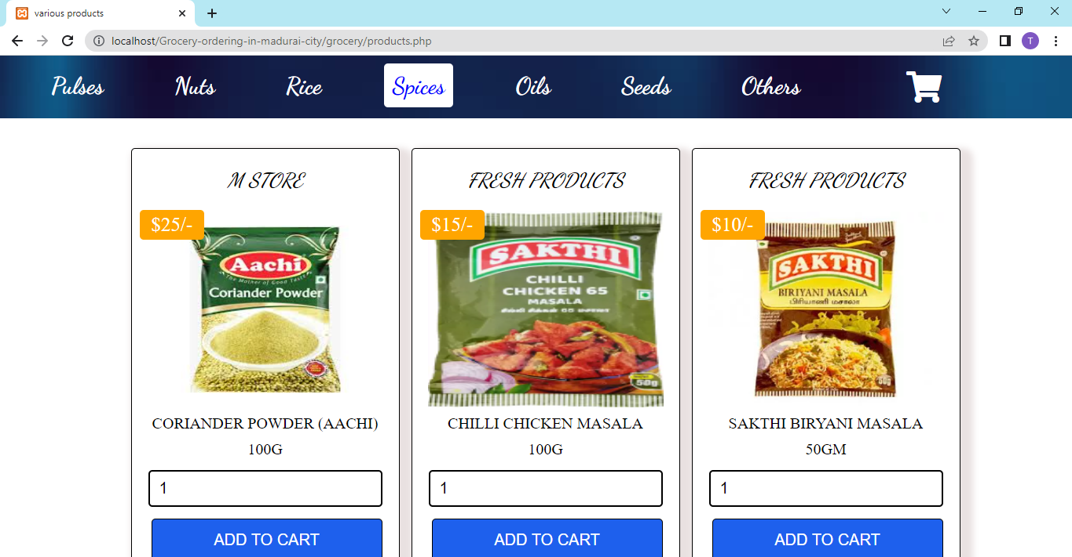

**OILS**

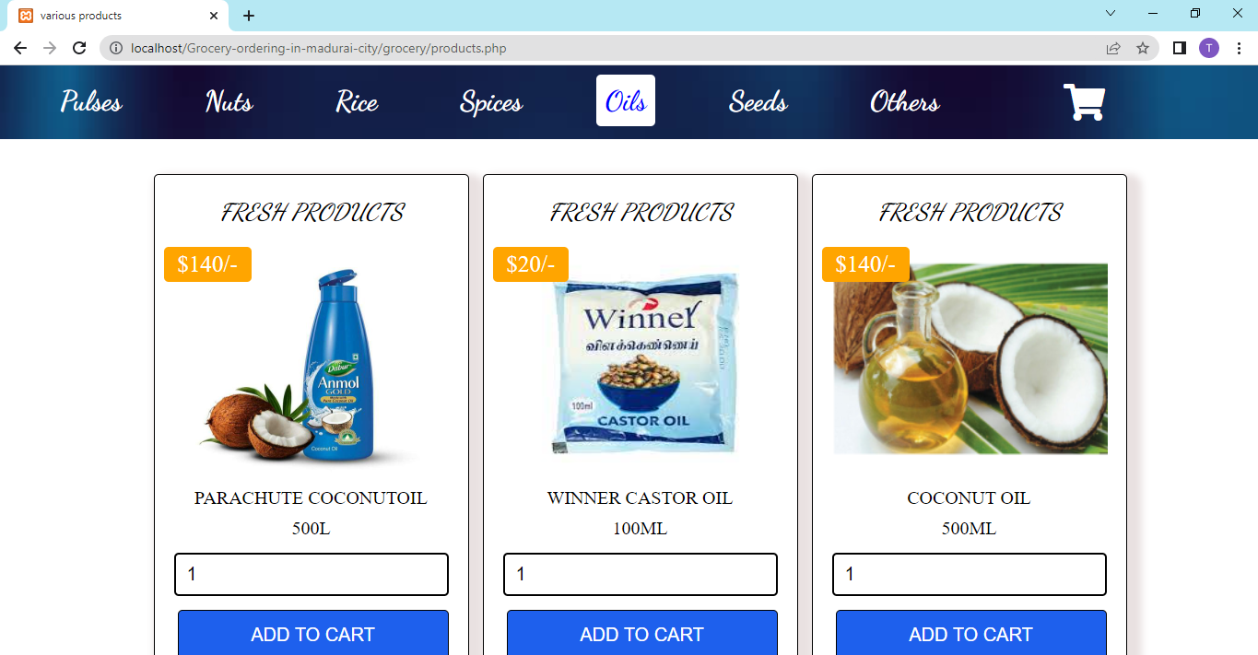

**SEEDS**

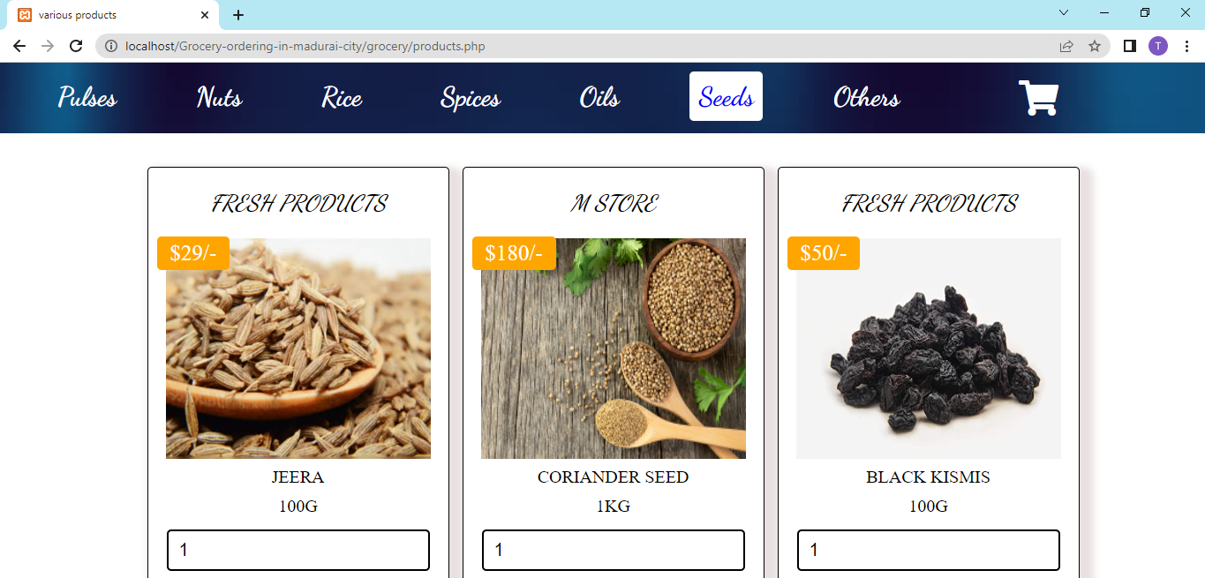

**OTHERS**

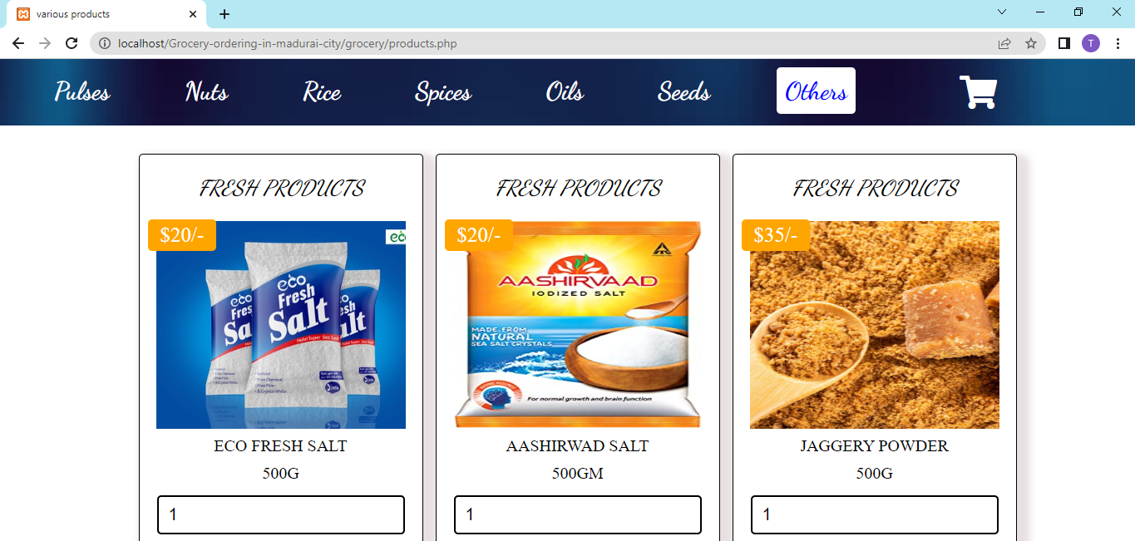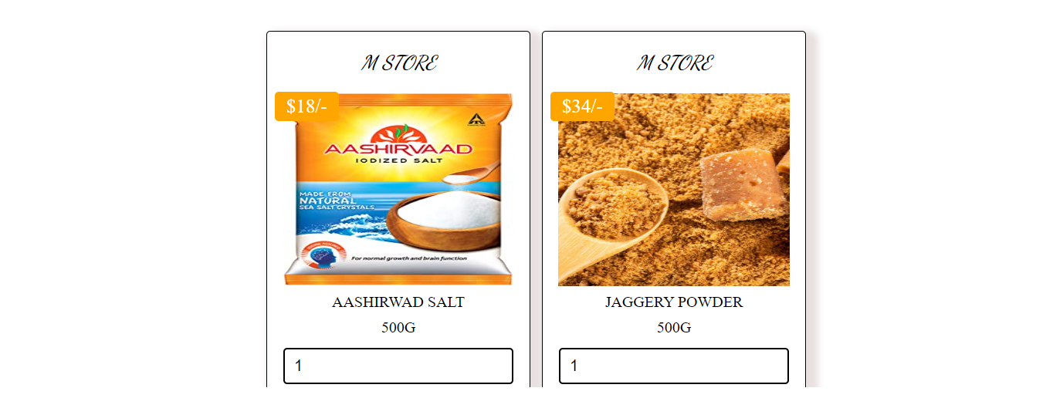

**CART – ITEMS ARE NOT ADDED**

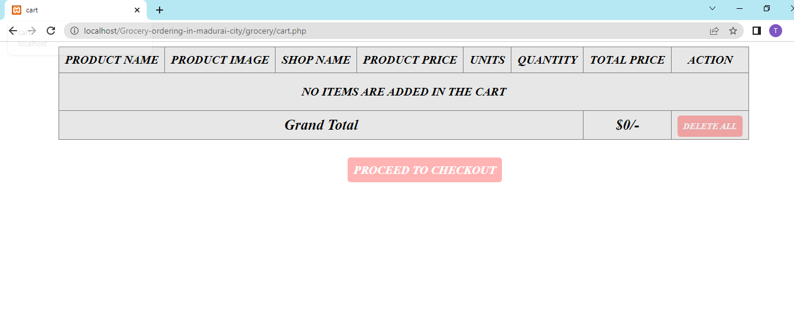

**CART – ITEMS ARE ADDED**

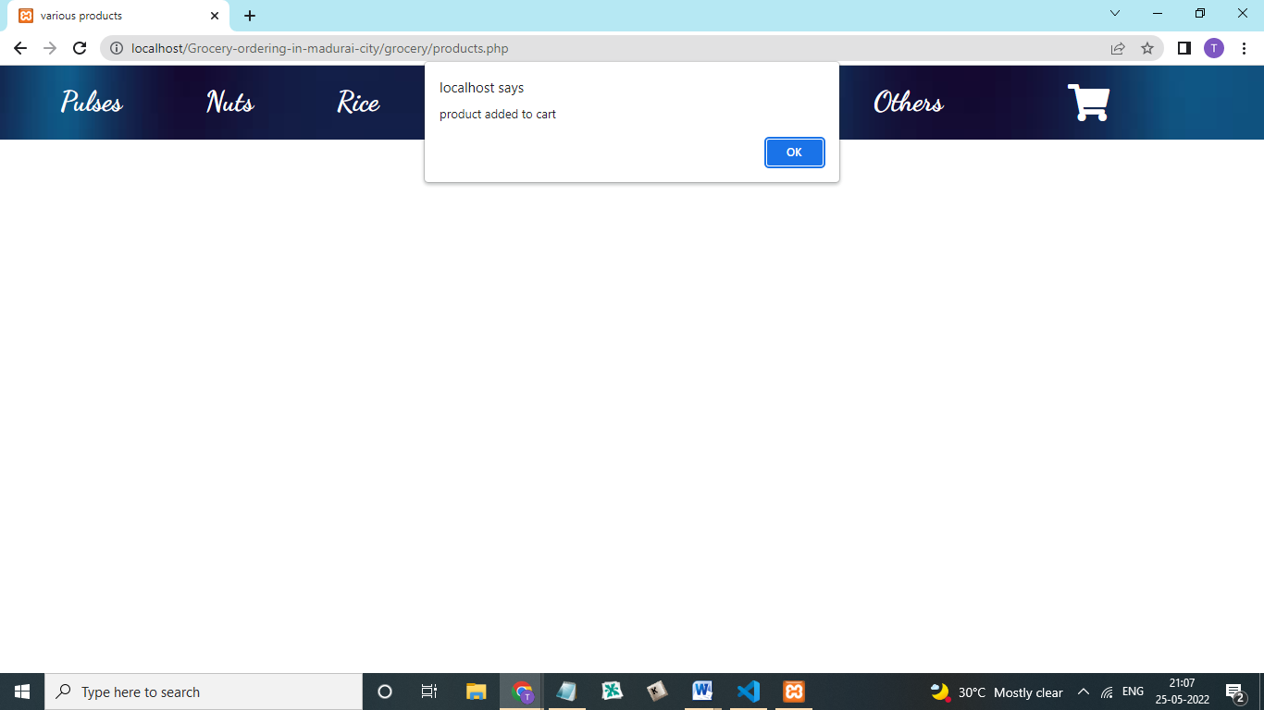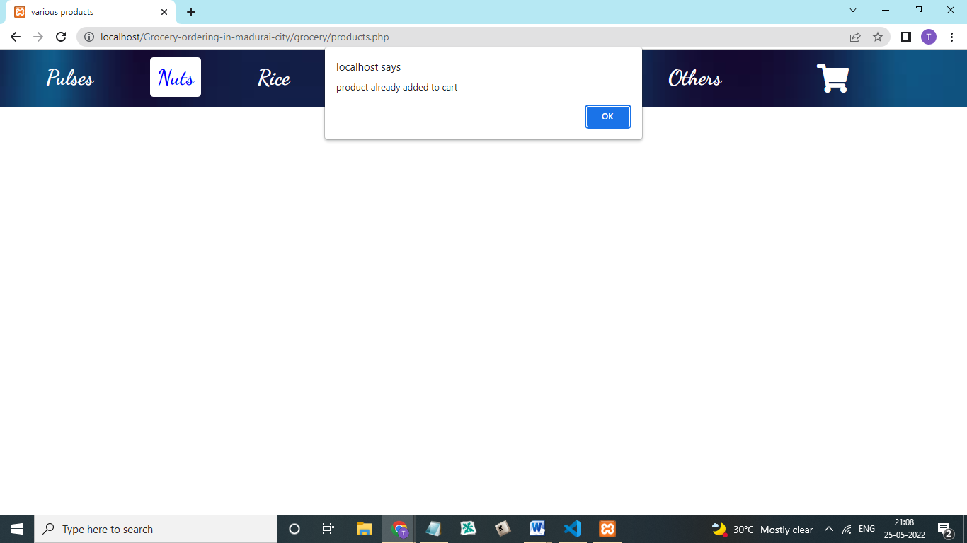

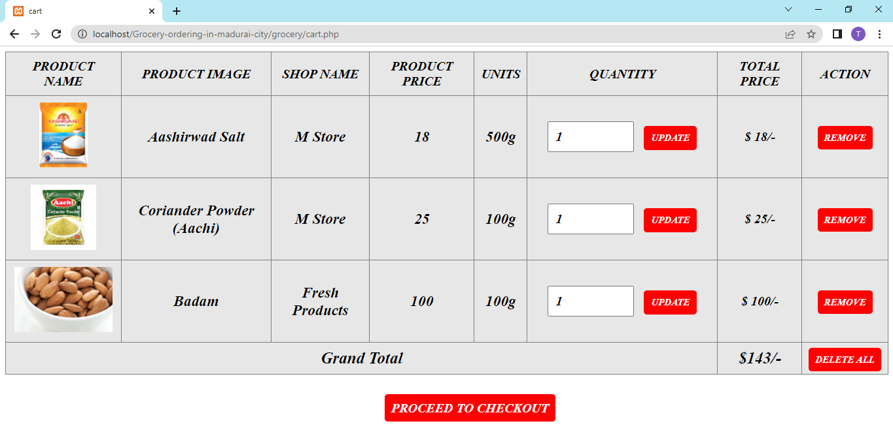

**CUSTOMER DETAILS**

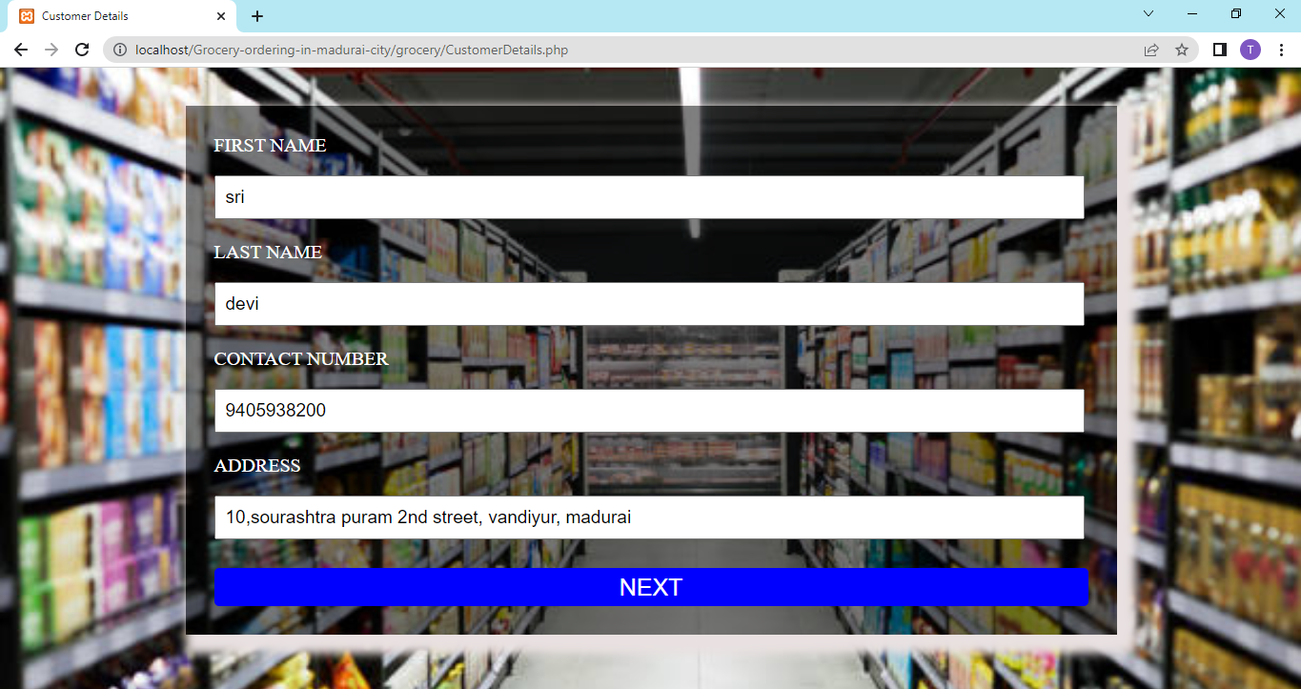

**PAYMENT**

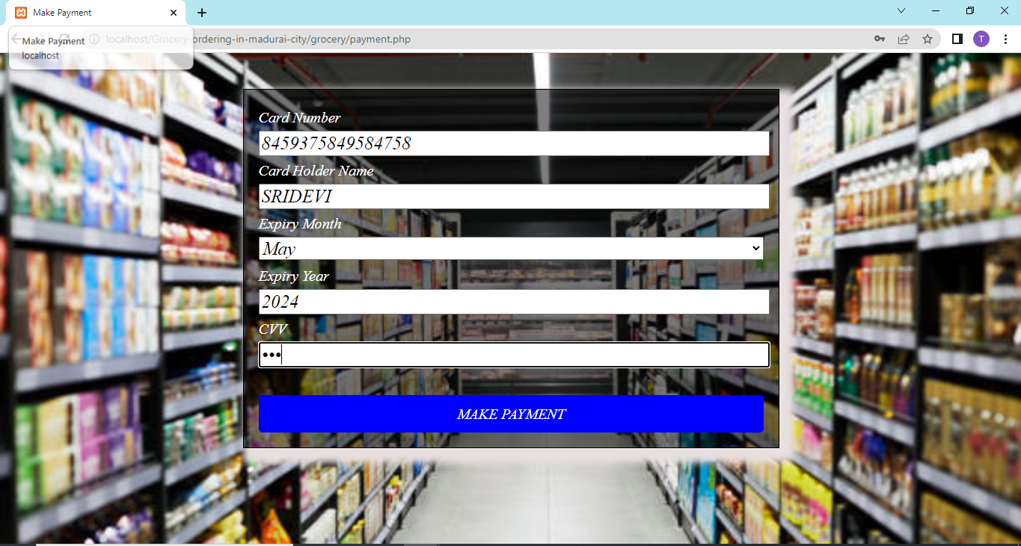

**MY ORDERS**

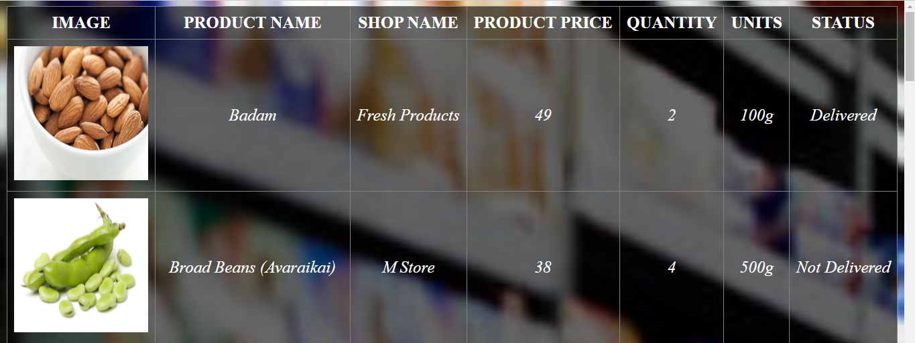

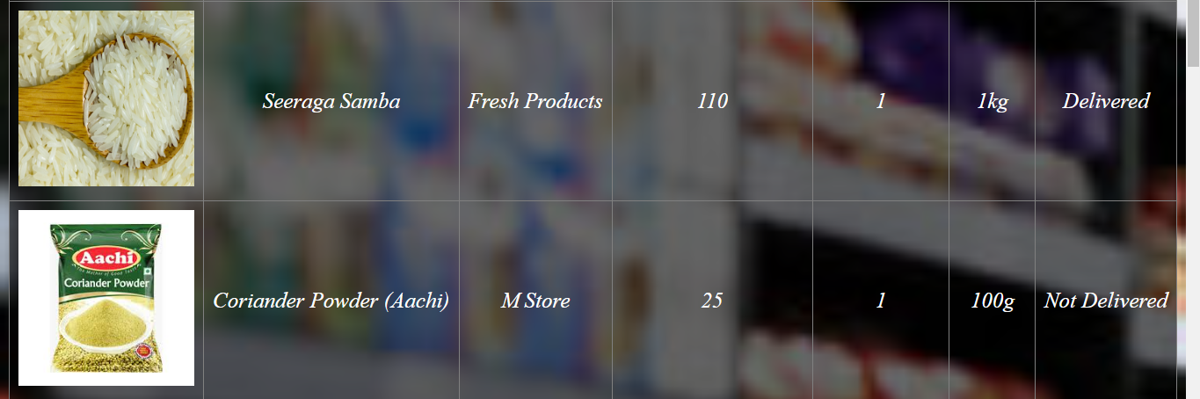

# CONCLUSION

#### 8.CONCLUSION

As grocery is one of the basic human needs, the business is here to stay for a long time. And with the increased penetration of smartphones and internet, users keep looking for simple ways to complete their daily tasks. We can order the grocery items anytime, anywhere. It is user friendly, which also increases the number of customers and enhances customer relationships. Also, web stores are a means for small-scale companies to launch their products at the global level.

**FUTURE ENHANCEMENT**

#### 9. FUTURE ENHANCEMENT

The project made here is just to ensure that this product could be valid in today real challenging world.It is not possible to develop a system that makes all the requirement of the user. User requirement keep changing as the system is being used.

* Customers can make payment online through their debit card, credit card.
* Add voice assistant rather than to search an item.
* Billing system will be include in future enhancement.
* For sellers, their product has access to the World-Wide market,
* As the technology emerges, It is possible to upgrade the system and can be adaptable to desired environment.
* We know that convenience is king, So more functionality will be added depending upon the user requirement and specification.

# BIBLIOGRAPHY

### 10.BIBLIOGRAPHY

#### 9.1 REFERENCES

#### [www.w3schools.com](http://www.w3schools.com)

#### [www.tutorialspoint.com](http://www.tutorialspoint.com)

#### <https://css-tricks.com>

#### PHP: A Beginner’s Guide – First edition by Vikram Vaswani